Group 13

37 Mikil Lalwani

56 Nilay Pophalkar

58 Sanskruti Punyarthi

61 Shree Samal

**CA 1 - Interfacing of minimum three sensors and minimum two Actuators with minimum three different hardware platforms.**

**Description of the application -**

1. Ultrasonic Sensor: An ultrasonic sensor uses high-frequency sound waves to measure distances. It emits sound pulses and calculates the time it takes for the echoes to return, enabling it to determine object proximity or presence. This technology is widely applied in robotics, obstacle detection, and parking assistance systems due to its accuracy and versatility.
2. Motion Sensor (PIR): A motion sensor, specifically Passive Infrared (PIR), detects changes in infrared radiation caused by moving objects. When a warm body crosses its field of view, it triggers an electrical signal. PIR sensors are commonly used in security systems, lighting control, and automation, providing efficient and reliable motion detection.
3. LDR Sensor (Light-Dependent Resistor): An LDR sensor changes its resistance based on the intensity of incident light. When exposed to light, its resistance decreases, and in darkness, it increases. LDR sensors find applications in automatic lighting systems, cameras, and solar energy devices, adjusting their behavior according to ambient light levels.
4. LED (Light-Emitting Diode): An LED is a semiconductor device that emits light when an electric current passes through it. LEDs are widely used for visual indicators, displays, and lighting due to their energy efficiency, compact size, and long lifespan.
5. Buzzer: A buzzer is an electroacoustic device that produces a sound or tone when an electric current is applied. It is commonly used in alarms, notifications, and electronic devices to provide audible alerts or signals. Buzzer sounds vary in pitch and duration depending on their design and application.

**Sensors -**

Ultrasonic sensor, Motion sensor, LDR sensor

**Actuators -**

Led, Buzzer

1. Arduino

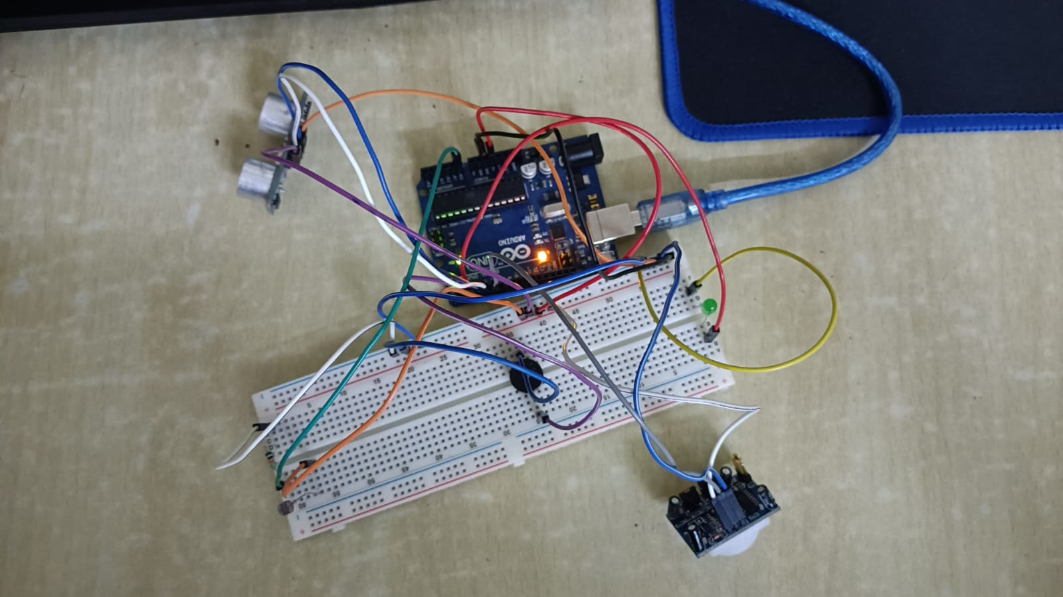

Code -

int ul_trig = 5;

int ul_echo = 4;

int buzzer = 2;

int led = 3;

int sensor = 6;

int state = LOW;

int pr = A0;

void setup() {

pinMode(ul_trig, OUTPUT);

pinMode(ul_echo, INPUT);

pinMode(buzzer, OUTPUT);

pinMode(led, OUTPUT);

pinMode(sensor, INPUT);

pinMode(pr, INPUT);

Serial.begin(9600);

}

void loop() {

// Ultrasonic Sensor

Serial.println();

Serial.println("Ultrasonic Sensor");

digitalWrite(ul_trig, HIGH);

delay(100);

digitalWrite(ul_trig, LOW);

int duration = pulseIn(ul_echo, HIGH);

Serial.print("Distance in CM: ");

Serial.println(duration / 58);

Serial.print("Distance in inches: ");

Serial.println(duration / 148);

if(duration/58<10){

digitalWrite(buzzer, HIGH);

}

delay(2000);

digitalWrite(buzzer, LOW);

delay(1000);

// Pir sensor

Serial.println();

Serial.println("PIR Sensor");

int val = digitalRead(sensor);

Serial.println(val);

if (val == HIGH) {

digitalWrite(led, HIGH);

digitalWrite(buzzer, HIGH);

delay(500);

digitalWrite(buzzer, LOW);

delay(2500);

digitalWrite(led, LOW);

}

//photoresistor

Serial.println();

Serial.println("LDR");

int photo = analogRead(pr);

Serial.println(photo);

if (photo > 180)

{

Serial.println("Light present");

}

else{

Serial.println("Light absent");

digitalWrite(led,HIGH);

delay(1000);

digitalWrite(led,LOW);

}

delay(1000);

}

Ultrasonic + buzzer-

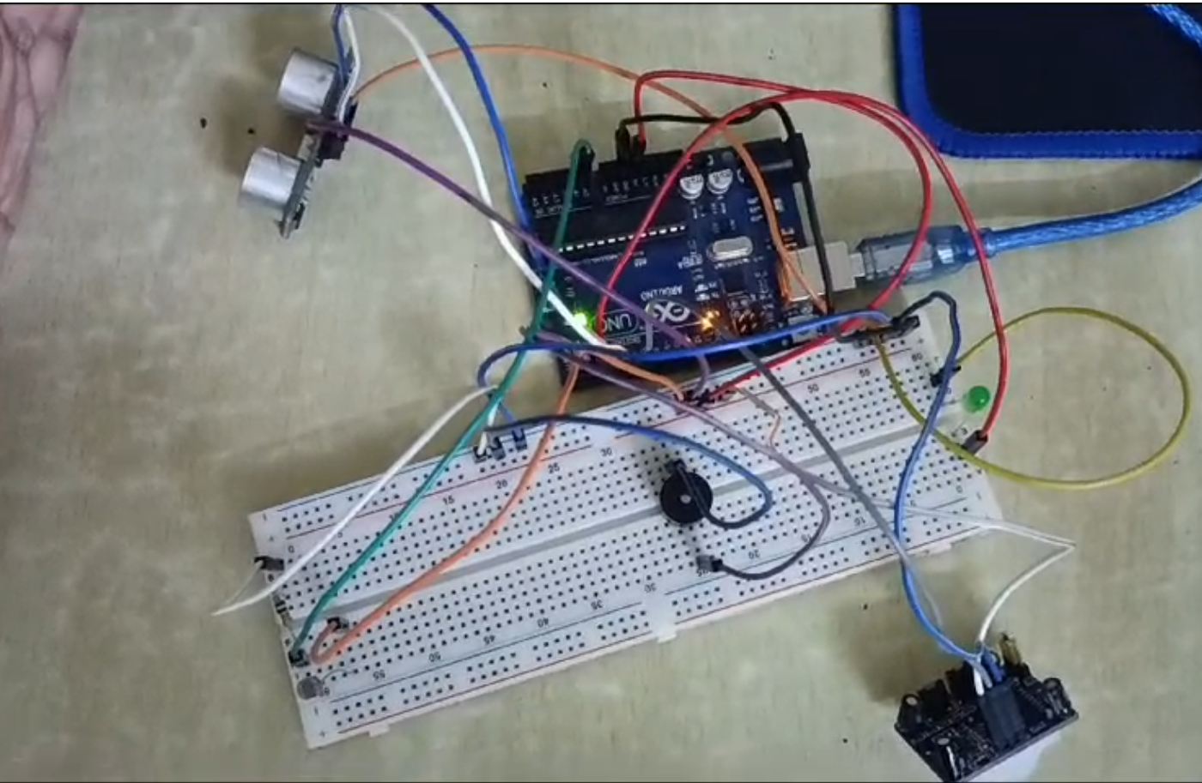

PIR + LED + buzzer -

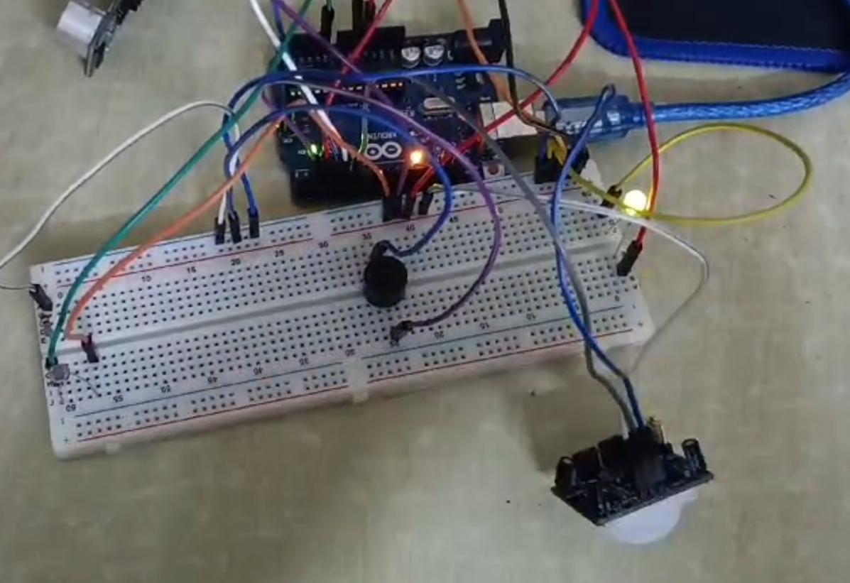

LDR + LED -

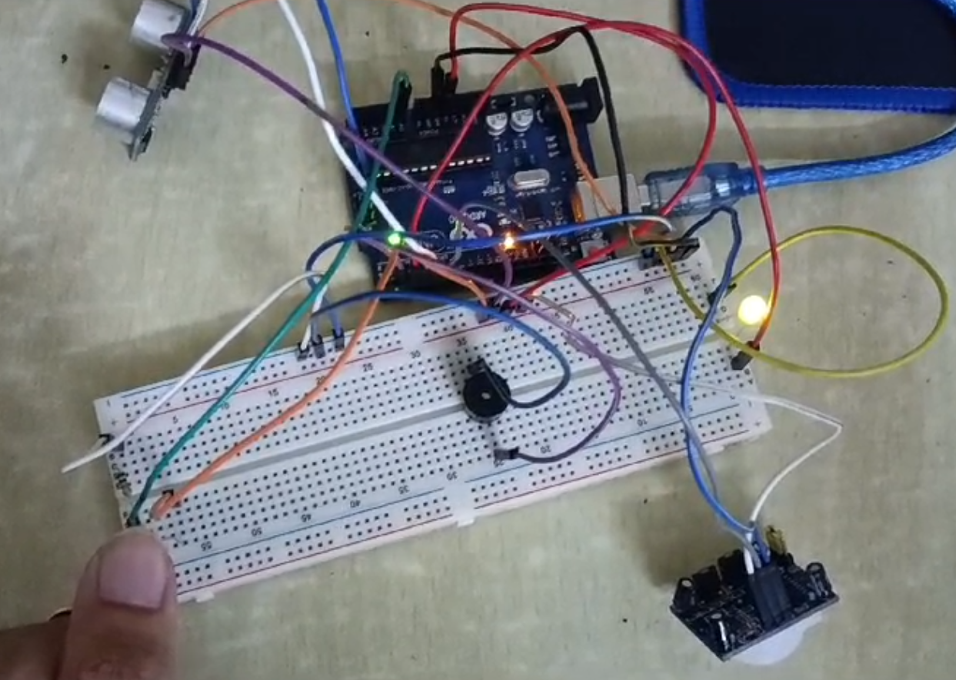

1. ESP -

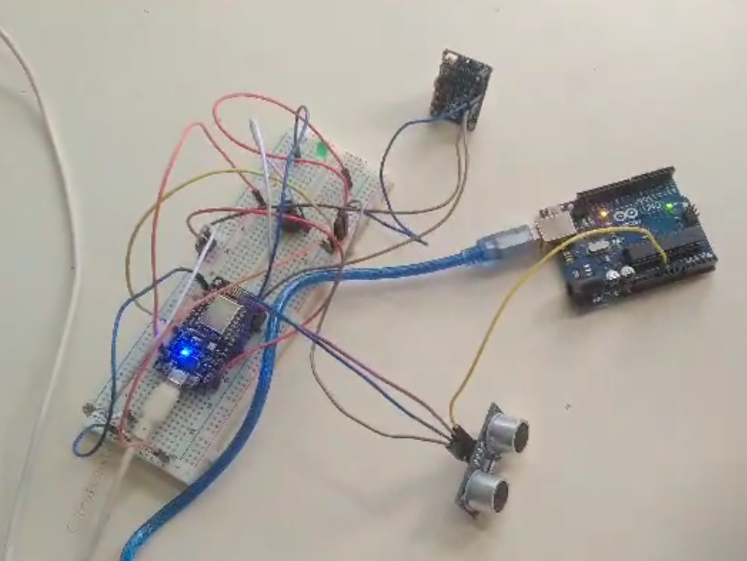

Code -

int ul_trig = 4;

int ul_echo = 5;

int buzzer = 16;

int led = 12;

int sensor = 14;

int state = LOW;

int pr = A0;

void setup() {

pinMode(ul_trig, OUTPUT);

pinMode(ul_echo, INPUT);

pinMode(buzzer, OUTPUT);

pinMode(led, OUTPUT);

pinMode(sensor, INPUT);

pinMode(pr, INPUT);

Serial.begin(9600);

}

void loop() {

// Ultrasonic Sensor

Serial.println();

Serial.println("Ultrasonic Sensor");

digitalWrite(ul_trig, LOW);

delayMicroseconds(2);

digitalWrite(ul_trig, HIGH);

delayMicroseconds(10);

digitalWrite(ul_trig, LOW);

long duration = pulseIn(ul_echo, HIGH);

int distanceCm = duration * 0.034/2;

int distanceInch = distanceCm * 0.393701;

Serial.print("Distance (cm): ");

Serial.println(distanceCm);

Serial.print("Distance (inch): ");

Serial.println(distanceInch);

if(distanceCm < 25){

digitalWrite(buzzer,HIGH);

delay(2000);

digitalWrite(buzzer,LOW);

}

delay(1000);

// Pir sensor

Serial.println();

Serial.println("PIR Sensor");

int val = digitalRead(sensor);

Serial.println(val);

if (val == HIGH) {

digitalWrite(led, HIGH);

digitalWrite(buzzer, HIGH);

delay(500);

digitalWrite(buzzer, LOW);

delay(2500);

digitalWrite(led, LOW);

}

delay(1000);

//photoresistor

Serial.println();

Serial.println("LDR");

int photo = analogRead(pr);

Serial.println(photo);

if (photo > 600)

{

Serial.println("Light present");

}

else{

Serial.println("Light absent");

digitalWrite(led,HIGH);

delay(1000);

digitalWrite(led,LOW);

}

delay(1000);

}

LDR + LED -

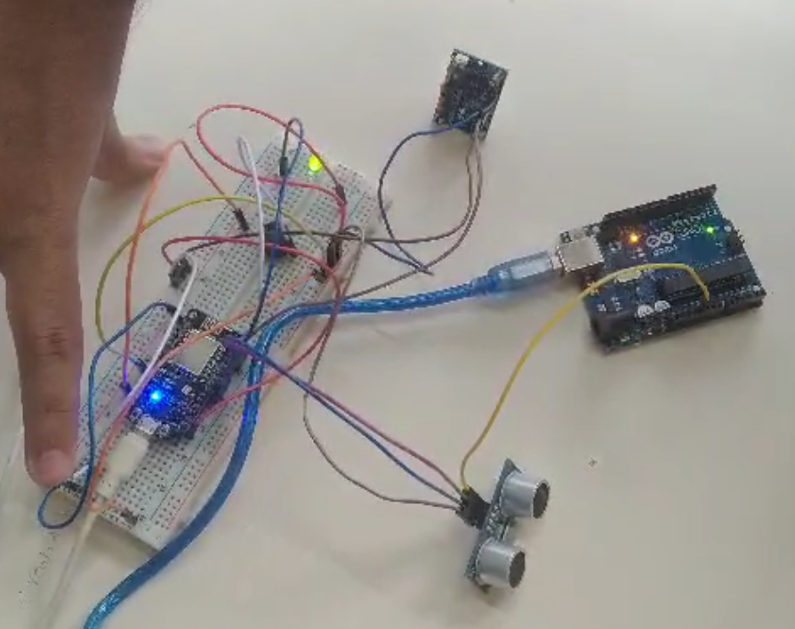

PIR + LED + Buzzer-

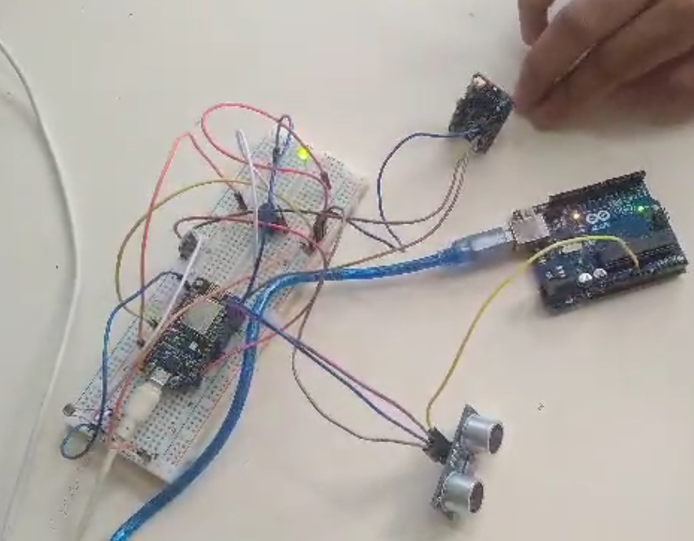

1. RaspberryPi -

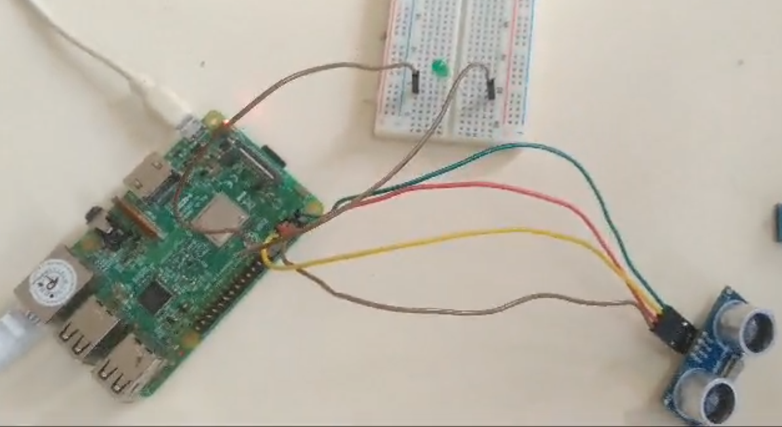

Code -

import RPi.GPIO as GPIO

import time

GPIO.setmode(GPIO.BCM)

GPIO.setwarnings(False)

led = 18

echo = 14

trig = 15

GPIO.setup(trig,GPIO.OUT)

GPIO.setup(echo,GPIO.IN)

GPIO.setup(led, GPIO.OUT)

try:

while True:

GPIO.output(trig, True)

time.sleep(0.00001)

GPIO.output(trig, False)

while GPIO.input(echo) == 0:

pulse_start = time.time()

while GPIO.input(echo) == 1:

pulse_end = time.time()

pulse_duration = pulse_end - pulse_start

distance = pulse_duration * 17150

print(f'Distane: {distance:.2f} cm')

if distance <= 20:

GPIO.output(led, GPIO.HIGH)

time.sleep(1)

GPIO.output(led, GPIO.LOW)

time.sleep(2)

except KeyboardInterrupt:

GPIO.cleanup()

Ultrasonic sensor + LED -

